Task 1: Visualize Customer Income Distribution grouped by Year of Registration
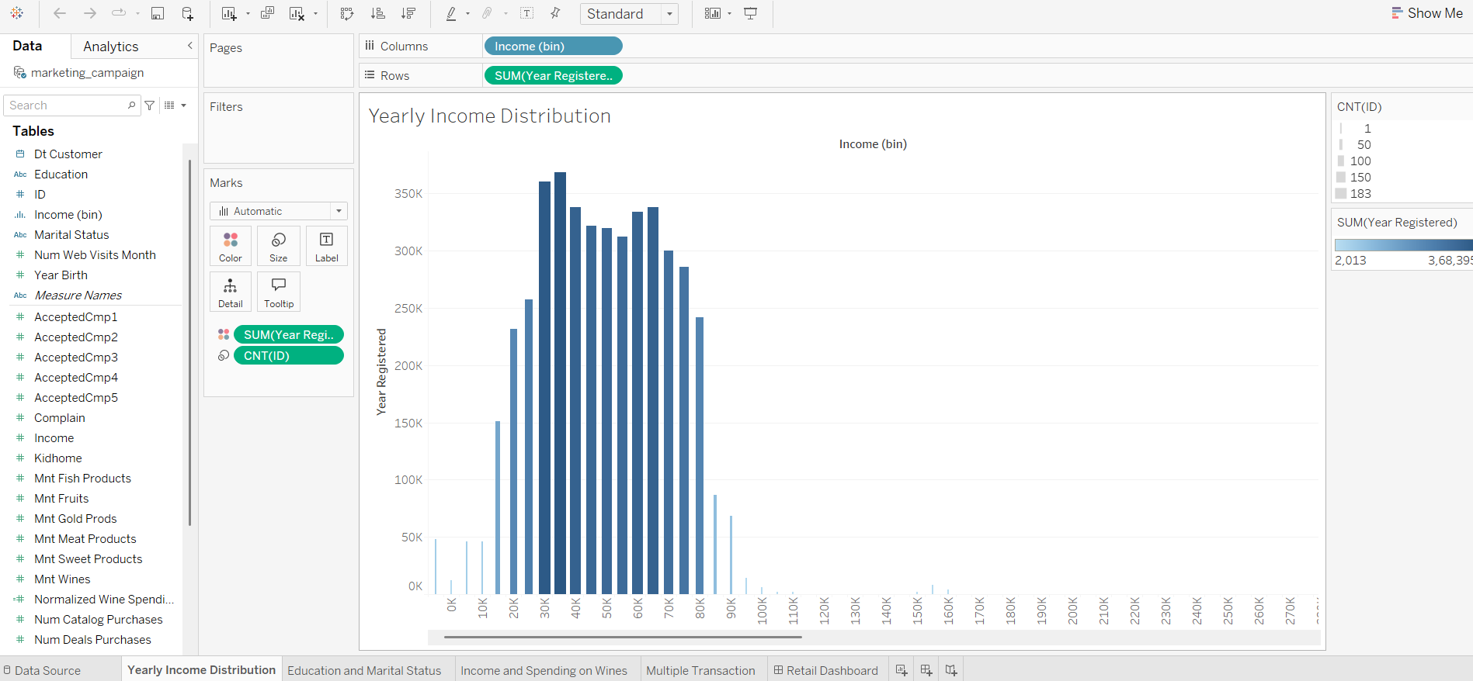

Task 2: Examine the breakdown of education levels and marital status using side-by-side circles to represent count

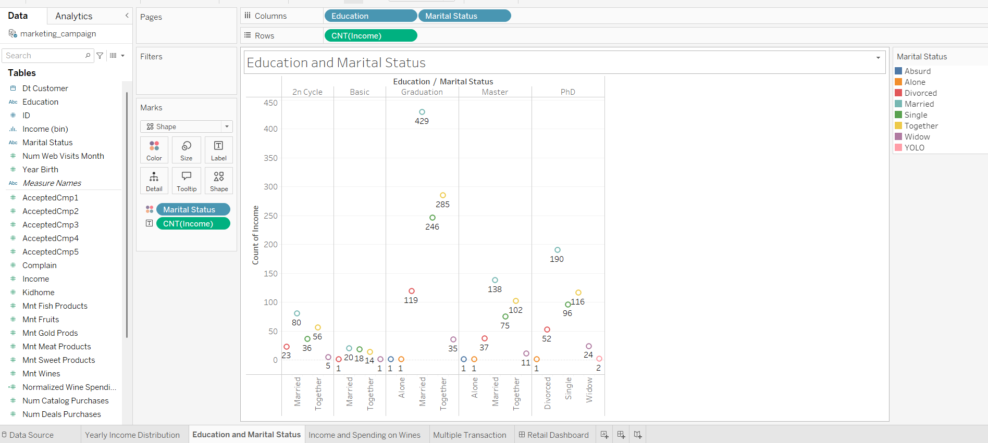

Task 3: Explore the relationship between Income and Wine Spending

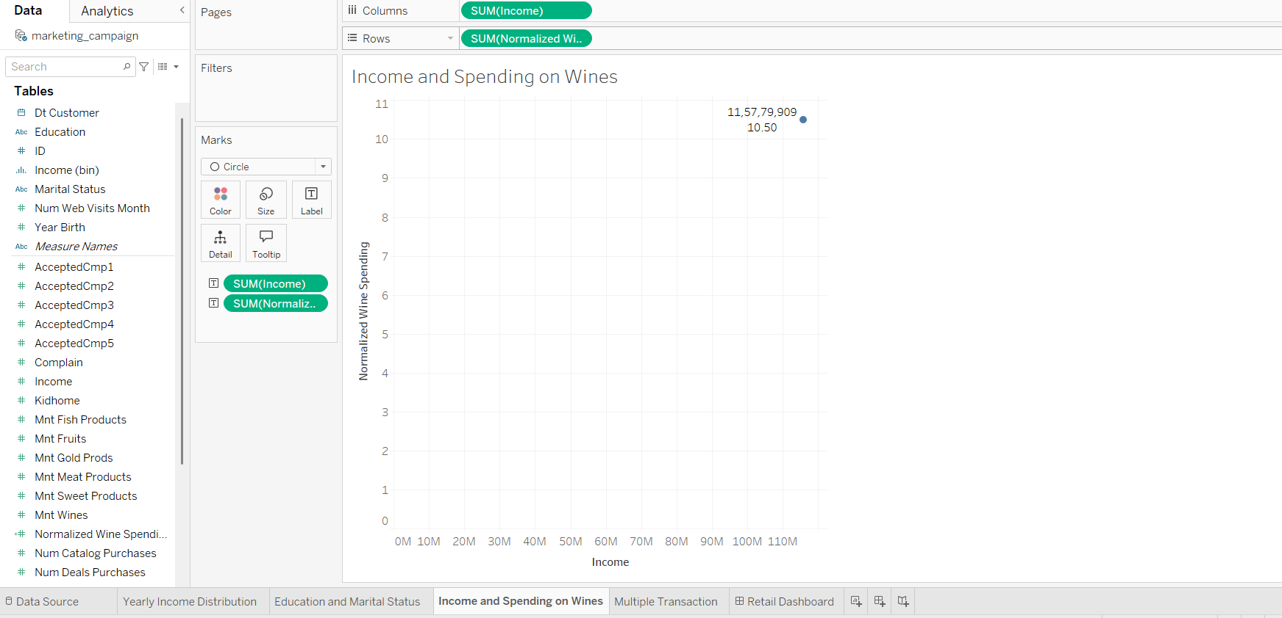

Task 4: Analyze the frequency of purchases across various product categories

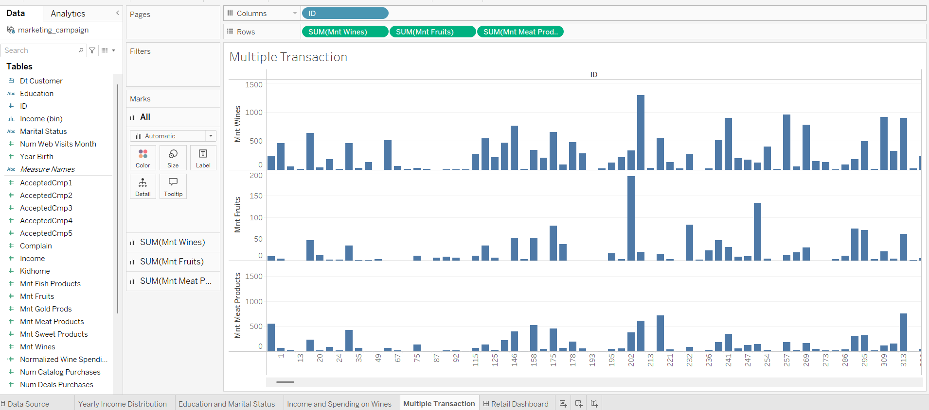

Task 5: Create a dashboard using all the visualizations

